Glossary | 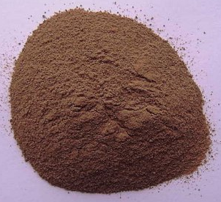  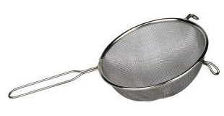  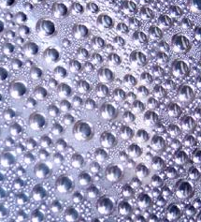  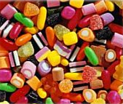  A sieve separates materials  Powder  Condensation  A mixture can be separated in different ways, e.g. sieving |  |  |  | solubility – a property of a material describing how well it will dissolve in a liquid
condensation – the process of change from a gas into a liquid  to condense - verb |  |  |  |  | solid – one of the three states of matter. Solids keep their shape. Ice is the solid state of water. Solids may be in the form of powders made up of very small particles
dissolve – when a solid becomes part of a liquid | 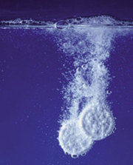  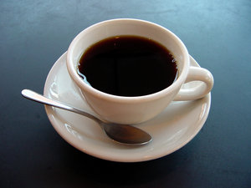  Some medicines dissolve in water, this means they are soluble. The tablet is the solute  This is a solution of instant coffee and water | 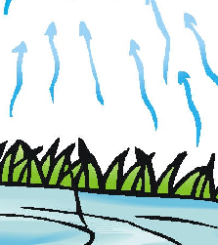  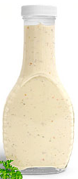  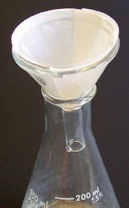  This salad dressing contains solids held in suspension  Evaporation is a change from liquid to gas  Separating fine solid particles from a liquid can be done using a filter |  |  | soluble – when a solid dissolves in water it is said to be soluble - opposite - insoluble
evaporation – the process of change from a liquid into a gas  to evaporate - verb |  |  |  |  | solute – the name given to a substance dissolved in a liquid
filter – to separate fine solid particles from a liquid |  |  |  |  | solution – a liquid that has a solid dissolved in it
filter – to separate fine solid particles from a liquid |  | 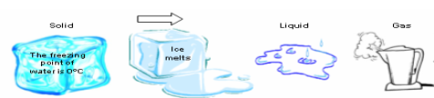  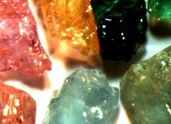  Impurities cause colour in gems. | 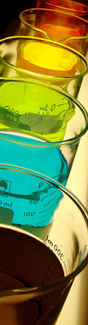  A solvent is a liquid in which a solid will dissolve, Solubility is how well it dissolves | 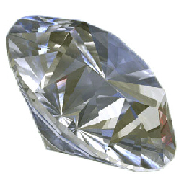  A diamond is a pure substance | solution – a liquid that has a solid dissolved in it
impurities – when a pure substance is contaminated with other materials |  |  |  |  | solvent – a liquid in which a solid will dissolve
liquid – one of the three states of matter. Liquids pour and take on the shape of the container. |  |  |  |  | state – All matter exists in one of three states – solid, liquid and gas
melt – to change from a solid into a liquid |  |  |  |  | suspension – a liquid containing tiny particles of solid that mix with the liquid but do not dissolve
mixture – a composite of different materials that can be separated by filtering, sieving, evaporation etc.
powder – a solid made up of very small particles |  | All matter is either in a solid, liquid or gas state
pure substance – matter that is not a mixture of things
sieve – to separate coarse solid particles from a liquid

